ANN - Answer Key

1. Why is feature scaling important for neural networks?
Feature scaling is important because neural networks are sensitive to the magnitude of input features.
Key Reasons:
- Neural networks use gradient descent, which converges faster when features are on a similar scale.
- Without scaling:
  - Features with large values dominate learning.
  - Training becomes slow or unstable.
- Activation functions like sigmoid and tanh saturate for large inputs, leading to vanishing gradients.
Conclusion:
Feature scaling ensures faster convergence, stable training, and better model performance.

2. What happens if sigmoid is replaced with ReLU in the output layer?
Replacing sigmoid with ReLU in the output layer causes incorrect behavior for binary classification.
Why?
- Sigmoid outputs values in the range [0, 1], suitable for probability.
- ReLU outputs values in the range [0, ∞).
Problems:
- Output is no longer a probability.
- Cannot interpret results as churn probability.
- Loss functions like binary crossentropy will not work properly.
Conclusion:
Sigmoid is required for binary classification output layers.

3. Modify the model to use three hidden layers
Modified Model:
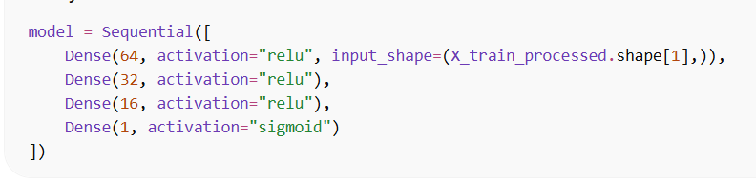
Explanation:
- More layers increase model capacity.
- Helps capture complex patterns.
- But may lead to overfitting if not controlled.

4. Change batch size and observe training behavior
Observations:
Batch Size | Behavior
Small (16, 32) | Noisy training, better generalization
Medium (32, 64) | Balanced performance
Large (128, 256) | Faster training, may generalize poorly
Explanation:
- Smaller batch → more updates → better learning but slower
- Larger batch → fewer updates → faster but less accurate
Conclusion:
Batch size affects speed vs generalization trade-off.

5. Add Dropout layers and compare accuracy
Modified Model with Dropout:
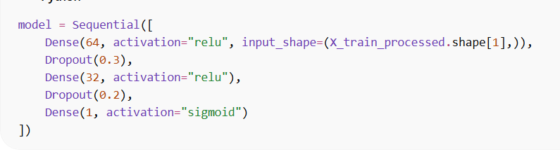
Observations:
- Training accuracy decreases slightly
- Validation accuracy improves
- Overfitting reduces
Explanation:
Dropout randomly removes neurons during training, forcing the network to learn robust patterns.
Conclusion:
Dropout improves generalization and reduces overfitting.

6. Explain why Adam converges faster than SGD
Adam = Adaptive Moment Estimation
Adam combines:
- Momentum (past gradients)
- Adaptive learning rates
Advantages over SGD:
- Automatically adjusts learning rate
- Faster convergence
- Works well with sparse data
- Less sensitive to hyperparameters
SGD:
- Uses fixed learning rate
- Slower convergence
- Requires tuning
Conclusion:
Adam is faster because it adapts learning dynamically for each parameter.

7. How does overfitting appear in training vs validation curves?
Pattern of Overfitting:
- Training accuracy → increases continuously
- Validation accuracy → stops improving or decreases
- Training loss → decreases
- Validation loss → starts increasing
Visualization Insight:
- Gap between training and validation curves widens
Conclusion:
Overfitting occurs when the model memorizes training data but fails to generalize.

8. When would you choose softmax over sigmoid?
Use Sigmoid:
- Binary classification
- Output = probability of one class
Use Softmax:
- Multi-class classification (3+ classes)
- Outputs probabilities for all classes
Example:
- Churn (Yes/No) → Sigmoid
- Customer type (Basic/Premium/VIP) → Softmax
Conclusion:
Softmax is used when predicting multiple mutually exclusive classes.

Summary Table
Concept | Key Idea
Feature Scaling | Improves training speed and stability
Sigmoid vs ReLU | Sigmoid needed for probability output
Deep Networks | Capture complexity but risk overfitting
Batch Size | Trade-off between speed and accuracy
Dropout | Reduces overfitting
Adam vs SGD | Faster convergence due to adaptive learning
Overfitting | Gap between training & validation
Softmax | Used for multi-class classification

